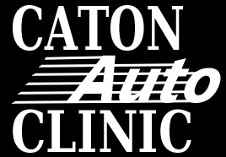
Breaks and Smoking Policy
We do provide for some cigarette breaks but we have certain requirements since you are in and out of customer’s cars. We also allow for lunch breaks during the day.
- You are allowed two 5 minute breaks- one before and one after your lunch break
- You are allowed 45 minutes a day for lunches.
- We do provide a lunch room for your enjoyment but, you may enjoy lunch anywhere.
- You may smoke in areas outside and away from public viewpoints:
  - Behind Brad’s bays
  - Behind fleet shop
  - Behind maintenance shop
- You must febreeze yourself OR use a cover up while smoking. This is to avoid the smoke odors from getting into customer’s cars which we did have some complaints on.

